CSC 122 001 Computer Science II

Julius Ranoa

Chapter 16 Programming Challenge 3 Min/Max Templates

Write templates for the two functions *min* and *max*. *min* should accept two arguments and return the value of the argument that is the lesser of two. *max* should accept two arguments and return the value of the argument that is the greater of the two. Design a simple driver program that demonstrates the templates with various data types.

Screenshot of runtime:

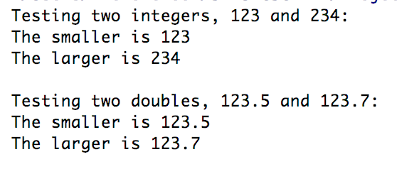

Files included: (1) main.cpp

**main.cpp**

#include **<iostream>**#include **<random>***// Definitions***template**<**class** T> T min(T, T);  
**template**<**class** T> T max(T, T);  
  
**int** main() {  
 **int** a, b;  
 **double** ax, bx;  
  
 *// Test case* a = 123;  
 b = 234;  
  
 ax = 123.5;  
 bx = 123.7;  
  
 std::cout << **"Testing two integers, "** << a << **" and "** << b << **": \n"**;  
 std::cout << **"The smaller is "** << min(a, b) << **"\n"**;  
 std::cout << **"The larger is "** << max(a, b) << **"\n\n"**;  
  
 std::cout << **"Testing two doubles, "** << ax << **" and "** << bx << **": \n"**;  
 std::cout << **"The smaller is "** << min(ax, bx) << **"\n"**;  
 std::cout << **"The larger is "** << max(ax, bx) << **"\n"**;  
  
 **return** 0;  
}  
  
*// Implementation***template**<**class** T> T min(T t1, T t2) {  
 **if** (t1 < t2) {  
 **return** t1;  
 } **else** {  
 **return** t2;  
 }  
}  
  
**template**<**class** T> T max(T t1, T t2) {  
 **if** (t1 > t2) {  
 **return** t1;  
 } **else** {  
 **return** t2;  
 }  
}